**F**or multiple units under one legal entity – you only need one QuickBooks Online subscription. By turning on the Location and Classes feature in the Account and Settings menu, you will be able to track and analyze transactions based on your units and run your reports accordingly.

**T**he Location and Classes feature may seem similar but have very specific functionality. **Location is for tracking an entire transaction while Classes is used for each line within a transaction.** Location tracking can be used for both profit-loss and balance sheet reports and analysis while Classes tracking is only used for profit-loss.

**L**ocation tracking will appear on your printed sales receipt and invoices, but Class tracking will not.

**P**lease note that you must submit your month-end reports to Sarah (Profit and Loss, Sales by Customer Summary) by location if you have two or more operational units.

**B**efore you can start using the Location and Classes feature in QBO, you must first turn it on in the Account and Settings menu then specify the name of your units in the List menu. Follow the steps below to activate this feature.

1. To turn on the Location and Class, select **Gear Menu** then select **Account and Settings**.

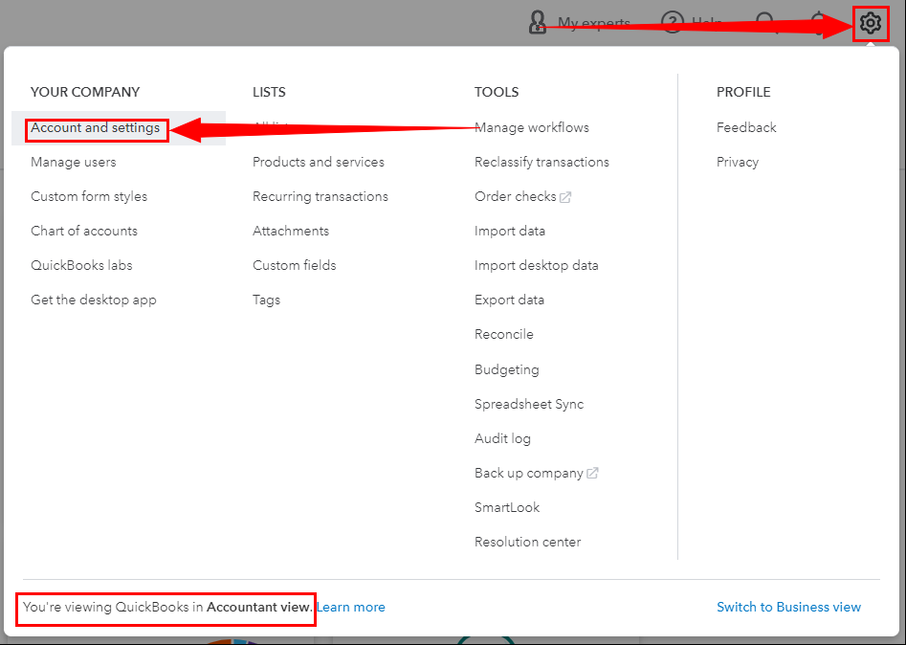

1. On the Account and Settings screen, select **Advanced.**

1. On the Advanced screen, click  on the **Categories** section to **edit**.

1. Turn on the sliders for **Track Classes** and **Track Locations** in the expanded Categories drawer then **Save**.

1. Once both features are activated, Graphical user interface, application, email

   Description automatically generated

**y**ou must specify the name of your units in the **List Menu.** Select **All List** on the Gear Menu.

1. On the **Lists Screen**, select **Location**.

1. Click **New** to add your Locations. *You must add each of your operational units*.

1. Fill out the **Location Information** as shown below then **Save**.

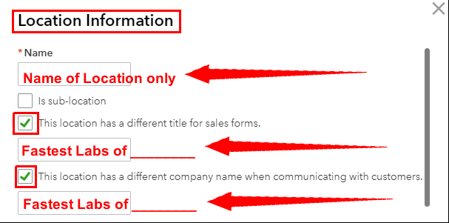

1. Click All List then on the Lists screen, select **Classes**.

1. Click **New** to add your Classes. *You must add each of your operational units*.

1. Fill out the Class box as shown below then **Save**.

**N**ow you are ready to use **Location** and **Class** tracking for your transactions. When recording a transaction in QuickBooks, make sure to select the correct Location and Class.

* Location and Class on an Estimate:

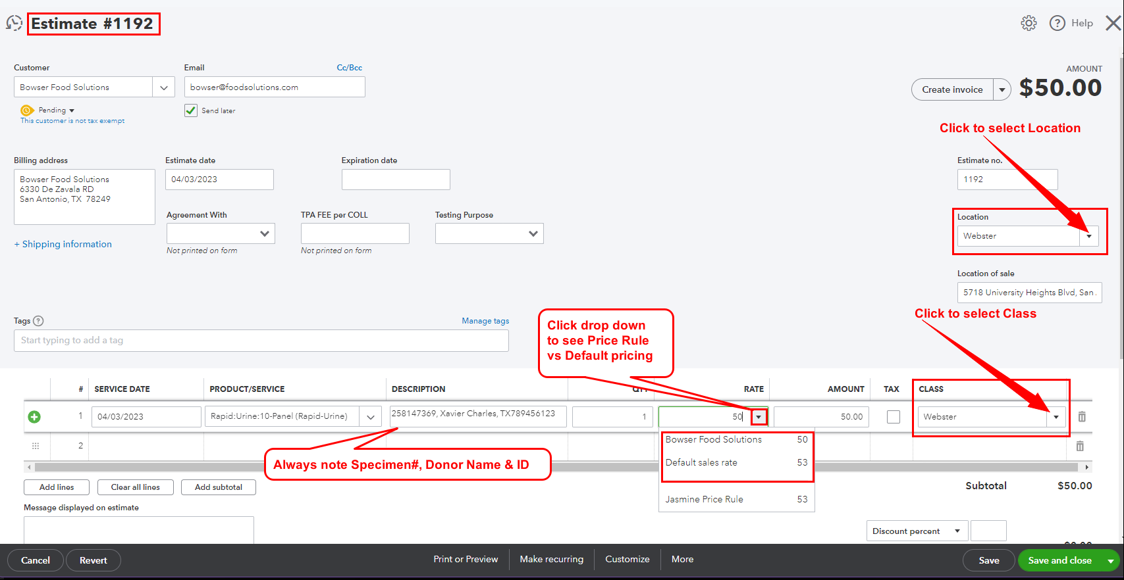

* Location and Class on an Invoice:

* Location tracking will appear on printed Sales forms.

* Use Class tracking to split an expense between you units

* Sales by Customer Summary Report

* Profit and Loss Report

